**Castle(Requirements)**

# Prices

* Local amenities (shops, restaurants)

# Quick history/biography of the castle

* How far from bus stop/train station when walking

# Opening times/closing times

# Disabled access?

# Phone number

# Link to website

* Open on maps

? Peak times/off-peak times.

# Postcode

#: put into the database

*: Use Google API

?: Have no idea

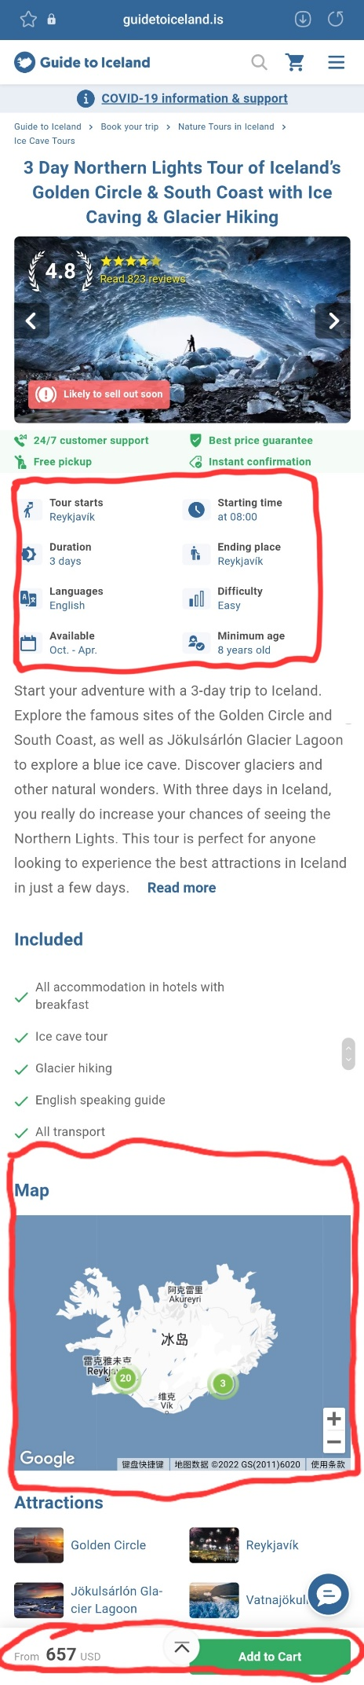

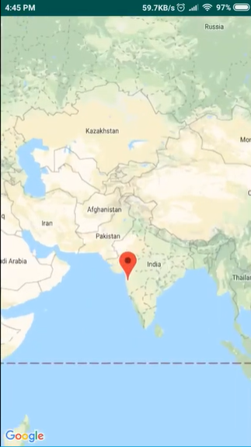 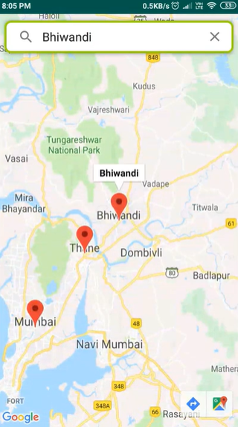

**How to use Google API**

<https://blog.csdn.net/mxsgoden/article/details/9770775>

<https://www.cnblogs.com/Renyi-Fan/p/9284367.html#_label2_5>

<https://blog.csdn.net/weixin_40875873/article/details/78409272>

<https://www.runoob.com/googleapi/google-maps-controls.html>

<http://www.blogjava.net/luyongfa/articles/388237.html>

<https://www.cnblogs.com/playing/archive/2011/04/23/2025419.html>

**Video:**

<https://www.youtube.com/watch?v=7TIAT5zlrmc&ab_channel=tutorialsEU>

<https://www.bilibili.com/video/BV1Fq4y1k7sx?spm_id_from=333.1007.top_right_bar_window_default_collection.content.click>

OR

<https://www.youtube.com/watch?v=eiexkzCI8m8>